Press release:
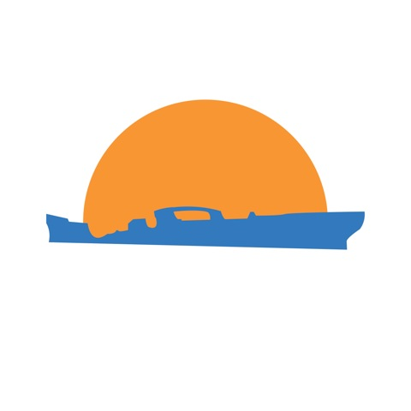ship to shore

public art event to raise awareness on our ocean’s environment. at the s.S. Palo Alto, Seacliff State Park (cement ship), May 22, 2013

Free and open to the public! 10 a.m.-1 p.m. Seacliff State Park, Aptos

The event kicks off with a beach clean up with Save Our Shores at 10 a.m. in Aptos, in front of the Snack Shack at Seacliff. The public will gain knowledge about plastic pollution and help clean the shore around the ship. Students from UCSC have created fun activities for the children to help them understand how our daily waste habits are hurting marine life, and ultimately, us.

Step down to the beach at 10 am Wednesday May 22nd to see "belly sculptures" collecting trash on the beach, handmade kites flying in the sky, ride a fish bike, join a parade and help clean the beach. UC Santa Cruz's Public Art Class with Associate Professor Dee Hibbert-Jones, Save Our Shores, and other marine organizations are launching the SS Palo Alto Project.

Come fly a kite, ride a fish-bike, join the parade and clean our beaches. Schools welcome. Tables of information will be on hand. Prizes for kids and take-home gifts. Proceeds will go to SOS and Friends of State Parks.

For more information on this long term environmental outreach and awareness research concept utilizing the arts, please visit: www.artmill.eu. Or see UCSC’s Social Practice Arts Research Center at www.sparc.edu. The Project is part of a larger long term international initiative working with the UN Safe Planet Campaign working to raise awareness on hazardous chemicals and wastes in the environment.Contacts: Barbara Benish, bbenish@ucsc.edu 831.818.8034Rachel Kippen, rachel@saveourshores.org 831.462.5660x3

